Tom’s Day
On Sunday, Tom at 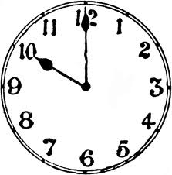. Then he his  in the 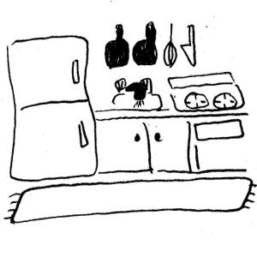. He has  at 11.30 and then he 
his mother in Scotland.

In the afternoon, at 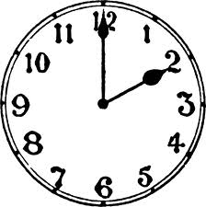, Tom  with his sister and after that, they eat dinner in a . At 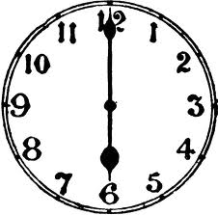, Tom for one hour and then he goes by 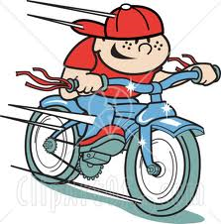 to his brother’s house.

Tom’s Day
On Sunday, Tom gets up at 10 o’clock. Then he reads his newspaper in the kitchen. He has breakfast at 11.30 and then he telephones his mother in Scotland.

In the afternoon, at one o’clock, Tom plays tennis with his sister and after that, they eat dinner in a restaurant. At six , Tom swims for one hour and then he goes by bike to his brother’s house.

